Vanik Council
Guidance on reducing Potassium (k) content for Gujarati vegetarian diet Meena Modi, OBE
Health Warning This is advice based on my personal experience and research. I am not a health professional. I have sought advice from Mansi Desai, Clinical Special Renal Dietician at Royal Free Hospital, London about the contents of this guidance as there is a real need for this in the vegetarian Asian especially Gujarati community.
For kidney patients with diabetes, it is advisable to check this advice with your renal dietitian.
My husband Kirit has gone through kidney failure twice. I donated a live kidney to him in 2001. I have managed his diet during kidney failures, particularly by reducing potassium from his meals whilst making sure meals were healthy, balanced and tasty.
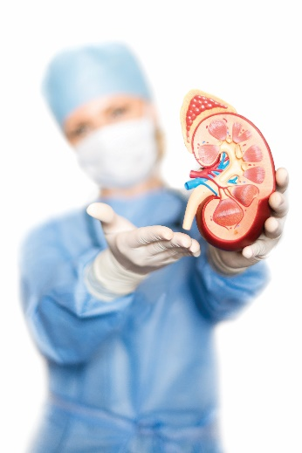
General advice
Kidney patients like everyone need to have a balanced healthy diet at all times. To maintain control over the potassium, kidney patients need to watch the amount they eat especially of foods in the high potassium bracket. There is potassium in everything we eat so one cannot avoid taking in some. Healthy kidneys can regulate the potassium needed by our bodies and dispose of additional unwanted potassium through urine amongst other waste products. Damaged or failing kidneys cannot maintain this balance.
High potassium can be dangerous to the heart. Kidney patients need to limit the daily potassium intake to 40-50mmol if possible.
The table below provides a list according to Low/Medium and High content per 100g of food.
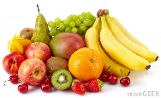
Fruits
LOW /MEDIUM k (< 200mg of k /100g of food) | HIGH k (>200mg of k/100g of food)
Apple | Amla
Lychee | Oranges
Blackberries | Fresh Apricot
Sweet lime | Plum
Guava | Ripe bananas
Pomegranate -dadum | Peach
Ripe papaya | cherries
Water melon | Mosambi
Pear | chikoo
Pineapple | Fresh coconut
Jambu | Sitafal
Strawberries | Grapes
Blackberries | Gooseberry
Raspberries | Kiwi
 | Lemon
 | Ripe mango
 | Melon
 | Mangoes
LOW /MEDIUM k (< 200mg of k /100g of food) | HIGH k (>200mg/100g of food)
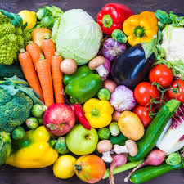 Vegetables
Dudhi, Marrow | Amaranth
Peas, Mangetout | Tomatoes
Papdi | Ringana
Karela (canned or boiled) | Beet root
Turiya | Broccoli
Raw banana | Okra/Bhinda
Capsicum/pepper | Corrinder-dhana
Cabbage, Carrots | Spinach
Cucumber | Saragva ni sing
Carrot | Parsnip
Methi | Mushrooms
Celery | Kantoda
Garlic, Spring onions | Raw papaya
Cauliflower- fulkobi | Saragavo/drumstick
Sweet corn-makai
tomatoes
Lettuce | Potato
French beans- fansi-poso
Green peas | Spinach
Okra- bhinda
Raw mango | Sweet potato
Onion
Parvar | Yam - mogo
Pumpkin
Tindora | Suran
Radish- mula
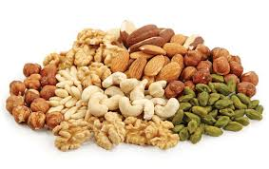Dry Fruits
 | Almond-Badaam
 | Cashew nuts- kaju
 | Dates- khajoor/kharek
 | Dry figs- anjeer
 | Raisins-draksh
 | Piastachios - Pista
 | Walnut- akhrot
 | Seeds
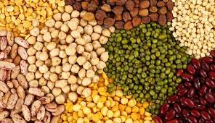
Cereals and Kathod (Limit the portion to ONE small bowl a day) and Nasto
Rice | Bajro
Barley- Jav
Rava- semolina | Ragi
Maida – plain /self raising flour | Gram Flour (Besan or chana no lot) and all savouries and sweets using gram flour.  Eg ganthia, sev, magaj and mohanthal
Green dried peas- | Whole wheat –brown atta
LOW /MEDIUM k (< 200mg of k /100g of food) | HIGH k (>200mg/100g of food)
Lila vatana | Kala chana
Juwar | Patra
Handavo (use Semolina) | Bateta vada
Farsi Puri | Kachori
White flour | Chick peas- Chana
Chakri | Chana daal
Noodles from wheat | Tuver daal
Popcorn | Masoor daal
Mamra | Mung & Mung daal
Pauva-rice flakes | Masoor
Wheat vermicelli -sev | Urad daal
Rice based snacks | Soya flour
Couscous | All Bran
Tapioca | Cereals containing nuts/ fruit/chocolate
Sago | Muesli
 | Jeeru
Bran flakes, corn flakes | Suki methi
Rice crispies | Dhana seeds
Weetabix, Shredded wheat | Dhana jeeru
Sunth– Dried ginger | Suka marcha- bhuko
Black pepper-mari | Turmaric/Haldar
Honey- madh | Tomato ketchup
Cloves-lavinga | Tomato sauce
Mint leaves- fudino | Any salt substitute
Cardamom-elaichi | Chocolate
Mustard-rai | Potato crisps
Garam masala | Potato chips
Nutmeg-jaifal | Condensed milk
Vinegar | Drinking chocolate
Buffalo milk | Coconut water
Skimmed or Semi skimmed milk | Fresh fruit juices
Soda water | Beer
Yoghurt | Wine
Home made lemonade | Fizzy drinks
Jam/marmalade | Nut butters
Salad cream / Mayonnaise | Butter, cream and Ghee( All Polysaturated fats)
Syrup- Golden , Maple
Vinegar
Fats/Oils
All fats/ oils are low in potassium
BUT better to use Monosaturated fats
Eg Rapeseed oil, Olive oil/spread

Basic guidelines for reduced potassium diet
- Avoid foods with high potassium content if possible.
- Use mostly foods from the low / medium potassium content.
- ALL kathod are high potassium foods BUT vegetarians need protein. Kathod is a key protein rich food for vegetarians so do not cut it out but reduce the potassium from kathod before cooking with it using the following method
- Soak the kathod for a few hours in plenty of water
- Remove the water and boil the kathod in plenty of fresh water till cooked
- Remove the extra water from the kathod by straining it
- Cook as normal
- This reduces the potassium content in the kathod by nearly half.
Eat no more than a small bowlful of kathod each day
- All masalas are high in potassium but we only use a small quantity so it is ok to use them sparingly
- Potatoes are high in potassium so AVOID jacket, roast or fried potatoes. You can have potatoes if boiled in plenty of water to reduce the potassium sometimes.
- All foods in the high potassium foods column can be used sometimes if the potassium is reduced first.
- Most exotic fruits are high in potassium so avoid them. It is good to have ONE apple OR ONE pear each day. Berries are generally safe to use. Tinned fruits have lower potassium so can use these sometimes.
- Avoid fruit juices.
- MILK is an essential food but restrict it to a small glass (300ml) daily. Skimmed milk is better.
- Avoid Coffee. Tea is better.
- Use white flour for chapattis. Use white bread.
- Use rice based cereals such as Rice Crispies . Avoid chocolate based cereals.
If you any queries, please do not hesitate to contact me at meenamodi@hotmail.com

