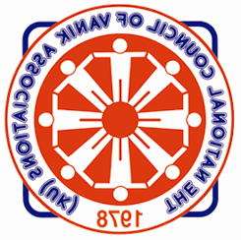
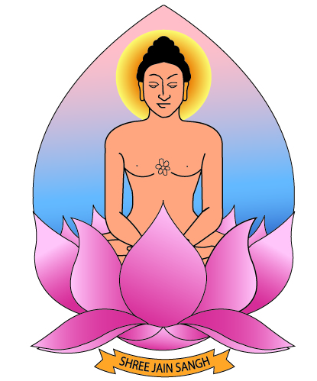
NCVA/SJS – Health Seminar – Sunday 3rd May, 2015
Review
The Health Seminar, held in East London at Hariben Bachubhai Nagrecha Hall on Sunday 3rd May was a resounding success!
This was a first joint event organised by National Council of Vanik Associations (NCVA) and Shree Jain Sangh (SJS). NCVA were the main sponsors and, with faultless co-ordination, we managed to make this an event to remember. SJS team was led by Harshida Mehta supported by young Dr Shaine Mehta and NCVA by Manharbhai Mehta. Planning for this started some 4 months earlier. Many professional youths from SJS were at the forefront of organising the Seminar.
A total of 275 Members from all areas attended. A coach was hired for those travelling from North London. Many came by car from North, West and South London.
The day started with a welcome speech by Harshida Mehta followed by talks on Diabetes by Dr.Pragna Mandalia, (Diabetes UK), Cancer Care by Jeanette Easton (Macmillan), Dementia by
Varsha Dodhia and finally Spiritual Healthcare by Manhar Mehta. The on-stage programme was co-ordinated by Dr. Shaine Mehta. All the talks were invigorating, informative and useful.
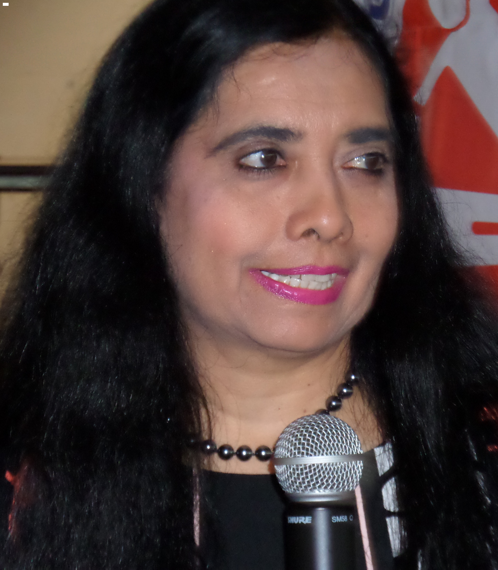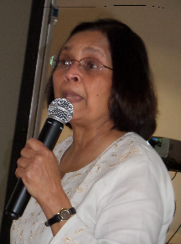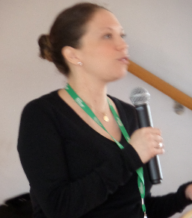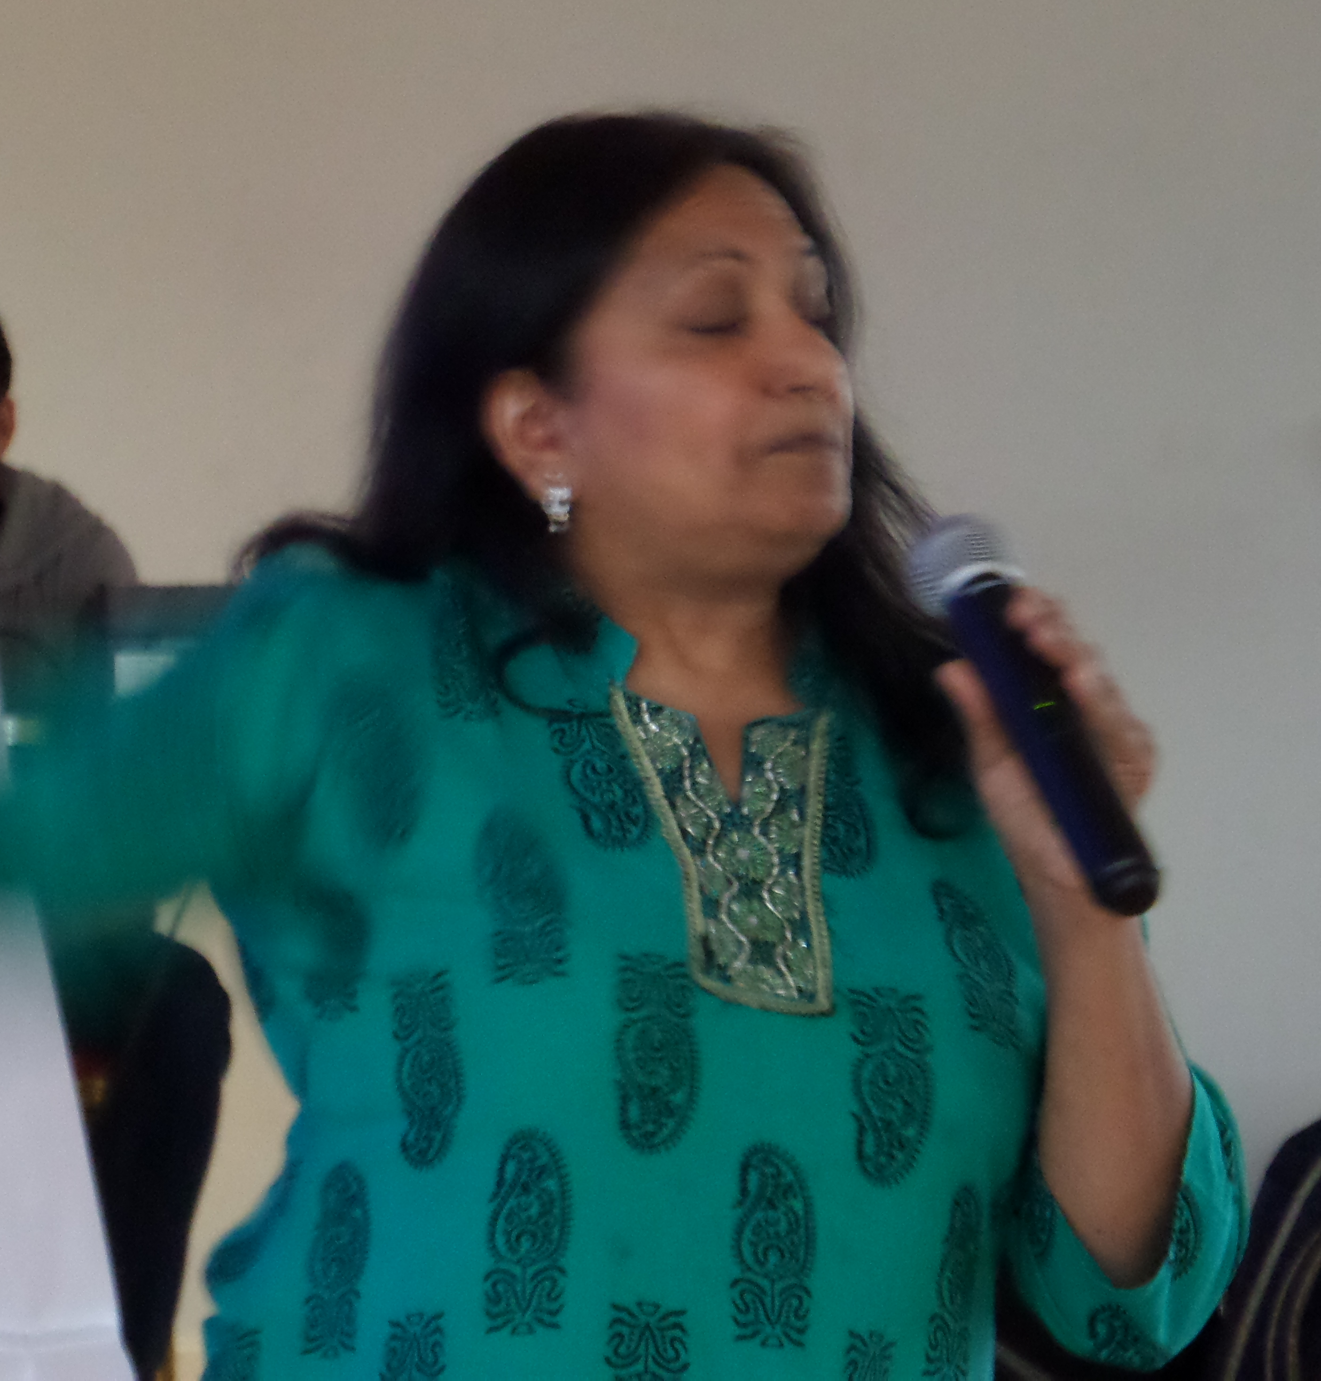 | 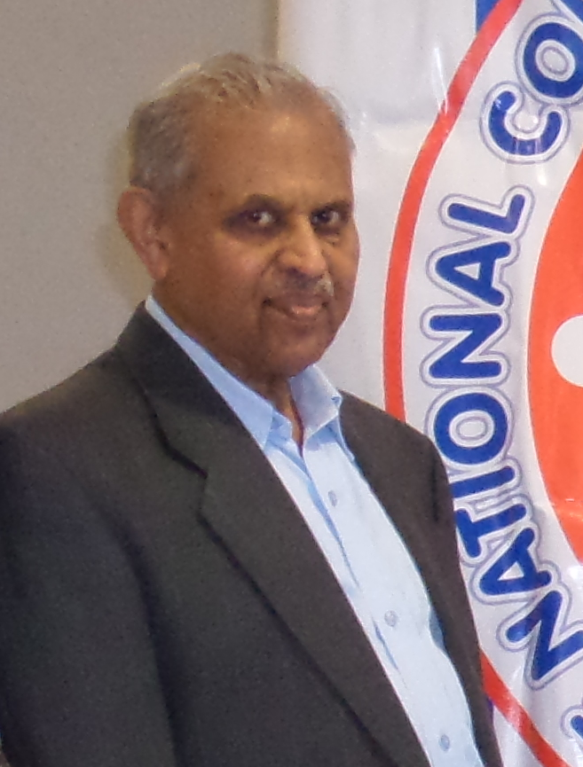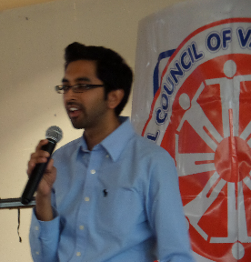

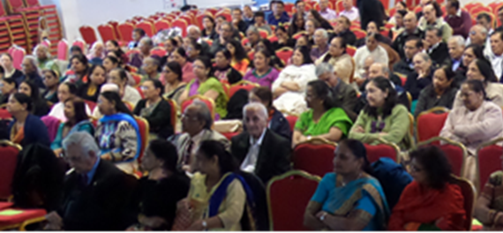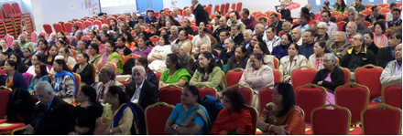

The audience have to be credited for being attentive and also for maintaining silence throughout the lectures. After the main talks, people attended workshops on (i) Vegan food led by Mahersh Shah, (ii) Oral Health led by Dr. Dipesh Kothari supported by Dr. Rima Doshi, (iii) Eye Care led by Vibha Vora supported by Reena Vora, (iv) Blood Pressure/Blood Sugar check ups conducted by our team of Pharmacists including Manish Shah, Dipak Doshi, Mayur Parekh and Nisha Mehta. A total of 120 tests were carried out and a few attendants were urged to contact their GPs for further check-ups. There were stalls for Cancer, Diabetes and Vegan food.
Bharat Mehta (NCVA Joint Secretary) and Harshad Kothari (SJS President) gave a vote of thanks.

